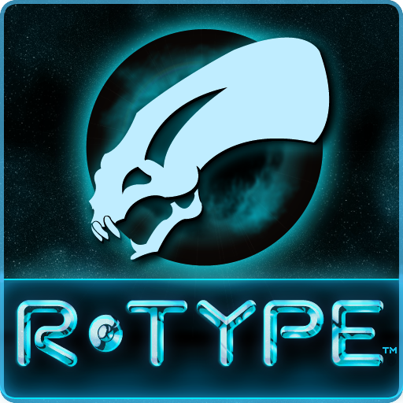

**R-TYPE  
IREM STUDIOS**

**Intended systems / platforms - Arcade**

**Target demographic – Teenagers and older**

**Intended ESRB rating (guess if needed) Release / Ship dates – ESRB E-Everyone**

# Table of Contents

|  |  |
| --- | --- |
| 1.0 Game Outline | 3 |
| 2.0 Characters  2.1 Description  2.2 Controls | 4 |
| 3.0 Initial Presentation | 5 |
| 4.0 Game World  4.1 Appearance | 6 |
| 4.2 Sound and Music | 7 |
| 5.0 Mechanics  5.1 Power-ups and Collectibles  5.2 Player Controlled Actions | 8 |
| 5.3 Enemies | 9 |
| 5.4 Bosses | 11 |
| 6.0 Monetization | 12 |

# 1.0 Game Outline

1.1 Game Story Summary

Blast off into space and defeat the evil Bydo Empire to save humanity!

### 1.2 Play Overview

The game has distinct start and ends of each Stage, where the player loses control of the ship. This gives them a moment to rest, or charge up before the next (or first) Stage begins.

After the final boss of a Stage is defeated, the plater becomes invulnerable, and the ship moves to a central location automatically. The Stage completion title is shown, and the score earned cumulatively is counted up.

To start the next Stage, the scores fade out and the Stage loads. The ship remains in the central location for the start of the next Stage. The player resumes control once the Stage has loaded.

### 1.3 Challenges

The player must stay alive until the end of the Stage, and defeat the Stage boss in order to progress.

Challenges include: enemy collisions, enemy projectiles, and collisions with the terrain or moving platforms and boss battles.

The player can over come these challenges by: shooting enemies, dodging enemy projectiles, preventing collisions. Bosses can be beaten by damaging their weak points.

The main challenge presented is that the ship is destroyed in 1 hit from any source. This means that no mistakes are allowed. The player must be the perfect pilot, or avoid damage completely to survive.

### 1.4 Progressing

Throughout the Stage, POW ships can be found. POW ships drop Force power-ups, which the player can collect. Collecting additional power ups increases force power. The force behaves differently depending on which of the 3 power up colours are collected by the player.

Players may also collect Bits, which can protect from projectiles and enemies either at the top or bottom of the ship. Players may have up to 2 bits, top and bottom.

The player is rewarded with points for each enemy defeated. The points awarded depend on the difficulty/toughness of the enemies killed. When the player has completed the game, or exhausted all lives available, their total score for the run is entered on the leaderboard. The top scores are then displayed, and the players rank is displayed in retaliation to all top scores on the machine.

### 1.5 Game Completion

To beat the game, the player must survive all Stages, and defeat the final boss. Doing so allows the player play the game a second time, increasing the maximum high score achievable.

2.0 Characters

### 2.1 Background

The player is a human fighter pilot, fighting to save humanity from the Bydo Empire, evil aliens that are an amalgamation of biological and mechanical life.

### 2.1 Description

The player is a space ship, with a blue, curved canopy. The ship belongs to the R-9 series of fighters, and is equipped with a rapid fire ray gun, and a chargeable wave cannon.

### 2.2 Controls

1. Joystick - Flight controls
2. Button 1 - Rapid fire (Vulcan Cannon)
3. Button 2 - Charge fire (Wave Cannon)
4. Button 3 - Toggles the attachment of the Force (if the player has one)

# 3.0 Initial Presentation

You start at the beginning of the first Stage, in deep space. The opening theme plays, letting the player know they are now in control of the R-9 spaceship. The stars begin to scroll as the Stage advances, and the first wave of enemy ships enters from the right side of the screen. As you defeat enemies and progress, you come to the entrance of a space station. You face increasing enemy defences, until you meet the first boss. To beat this boss, you must dodge its attacks and hit its weak point.

At the end of the Stage, your score is shown momentarily on the victory screen. After the score fades, the ship returns to the default position and the background and terrain of the next Stage fade in. The theme for Stage 2 starts playing, and the player is given control of the ship.

There is no story narrated to the player. The narrative is left for the player to infer, based on the Stages they complete and the bosses they defeat. Defeating the final boss brings about the end of the Bydo, and allows humans return to peace.

There are no mini games.

4.0 Game World

## 4.1 Appearance

The game world consists of 8 Stages, played in ascending order. All Stages have direct and constant lighting, allowing the player see all enemies on screen.

* Stage 1 takes the form of a space station entrance. You fight your way in, and defeat a boss to progress.
* Stage 2 is a laboratory, with glass containers and alien parts everywhere.
* Stage 3 has you destroy a hostile battleship. This ship turrets and deployed sentries are the main enemies, while its movement as you progress around it presents a navigational hazard
* Stage 4 is a special stage, where new enemies with construction capabilities appear. These enemies leave a trail of bricks behind them. Other enemies have the ability to tunnel through the bricks. Other enemies use the bricks as platforms.
* Stage 5 has you traverse a stage with foliage that enemies hide and ambush you from.
* Stage 6 is a factory/ industrial area. In addition to the usual scrolling Stage, there are now platforms moving through the Stage which the player must avoid. There are also a few enemies which crawl along walls, and shoot at the player.
* Stage 7 takes you through a waste facility. You see scraps and wreckages of previously defeated enemies repeatedly through the Stage, as if they are being recycled.
* Stage 8 looks like a nursery, and most of the enemies appear to be infantile in nature,

### Overall Aesthetic

The game should have a sci-fi look. Surfaces in Stages should match the Stage theme. Use of colour if important to convey the mood in the Stages.

### Menus

The game starts at the title screen, showing R-TYPE, and the instructions to blast off and defeat the Bydo empire. There is only one menu screen at the beginning of play. The player must insert a coin to begin the game. When a coin is inserted, the “insert coin” music plays, and opens up into the intro theme for Stage 1.

### Special Play Modes

There is a new game plus unlocked after completing the game the first time. In this mode, the player starts with the points earned in the previous play-through, and any bits they had at the end of the first run. The Force from Run 1 does not carry over to the new game.

### Cutscenes

There is a small cutscene for the game completion screen, where a closing message is displayed for the player.

### 4.2 Sound and Music

The music must stand out, even in a busy arcade hall. The following key music tracks are used in the game:

1. Menu: Ominous theme, should give the player the feeling that they are about to be faced by challenges.
2. An opening that gives the player a sense of exploring the unknown once a coin is inserted
3. Stage 1 theme is fast paced battle theme to inspire the player as they fight into the space station.
4. Stage 1 boss has an opening, and continues into Boss battle music with a dreadful tone. This us used for all bosses.
5. Boss defeat music should be celebratory in nature, and plays at the end of every level.
6. Stage 2 has music which builds a sense of dread, as the player is continuously ambushed as they fly through the Stage. Fast paced battle music with underlying dreadful tones.
7. Stage 3 music builds a sense of pressure and high stakes, as you fight a massive battleship.
8. Stage 4 quick attentive music. The Stage changes as it progresses, and a varied high pitched note weaves through the deeper tones.
9. Stage 5 theme should build a sense of caution and dread in the player. There are multiple ambushes, as the player goes deeper in search of the boss
10. Stage 6 is theme is bright and busy, and should fit the Stage of activity shown in the Stage.
11. Stage 7 shows the player the wreckages of defeated ships. The theme should help build a sense of anticipation, as the are almost at the final Stage, but must face the boss.
12. Stage 8 should build a sense of dread, as they battle towards the final boss.
13. Game clear theme should be happy and give the player a sense of honour and accomplishment. This only plays if a player can beat all the Stages.
14. High-score Music, should give the player warm feelings as they enter their score on the leaderboard. The game concludes here.
15. Closing theme after players enter their score, a short piece to signify that the game has ended

5.0 Gameplay Mechanics

## 5.1 Power-ups and Collectibles

There are 4 kinds: force, bits, seeking missiles, and speed power-ups. They last until death, or until the beginning of the new game. Only bits collected carry over into the second run.

1. Force – increases the players damage output. Fires when the player fires. The fire types are described below. The force blocks all standard enemy projectiles, and can protect from collisions with enemy ships.
2. Bits – These protect the player ship, either from above or below. The player may have 2 bits.
3. Speed – These increase the players agility
4. Homing Missile – This adds a pair of homing missiles to the R-9’s rapid fire. The 2 missiles fired must explode before more misses can be fired.

Power-ups are not necessary to complete the game, but greatly assist in clearing out enemies.

## 5.2 Player Controlled Actions

The player has control over the following, and must use these to survive:

1. Movement – The player can move freely in the X-Y plane. This lets the player dodge obstacles, enemies, and enemy projectiles.
2. Shooting – The player can choose to use the rapid fire ray gun, and each shot can only hit once. The player can also hold and charge up the wave gun for a powerful blast that goes through enemies until it hits a wall/goes off-screen.

The force modifies the players shots, depending on which of the 3 power-up colours was last collected. Red gives a ray wave which clears the centre direction from the player. Blue shoots diagonal beams which bounce off walls. Yellow gives a shot which goes completely vertical (up and down) and then runs along the walls it makes contact with. When it is not attached, the force shoots forward, up, down and in the two forward diagonals. It shoots the rapid fire ray gun.

1. Force toggle – The player can toggle on/off the attachment of the force. When the force is not attached, If free floats and follows the vertical elevation of the player, but not their horizontal position. A toggle calls the Force in to be attached at the ship’s front. The player can choose to circle around it, so that it attaches at their rear. When attached, a toggle sends the force forwards, and then it flies freely.
2. Lives – the player starts with 2 lives. Each death uses a life to restart the Stage. Lives are earned every
3. Hit Points – The player has 1 HP. Any collisions or hits sustained lead to instant death.

5.3 Enemies

All enemies in the game can be defeated by reducing their HP to zero. This can be done either with the rapid fire Vulcan cannon, the charged wave cannon, Force collisions, or bit collisions. Enemies with armour take significantly less damage, everywhere except their weak points.

The main enemy types are flying enemies, walking enemies, and stationary enemies/turrets.

Flying enemies

Movement does not have to be along terrain. All flying enemies either have a fixed pattern, or have flight patterns that are affected by the players position.

They are:

1. Wick – small green enemies, shaped like tadpoles. They fly in small groups and have fixed flight patterns.
2. Zoydo – Jellyfish like enemies, attack when the player is near, and try to swarm the player
3. Soar – discs of energy that fly in lemniscate patterns, based loosely on the player’s position. They are invulnerable, and can not be destroyed.
4. Slither – Enemies that are worm-like. They break apart into shrapnel when the head is destroyed.
5. Shell – This enemy appears as a ring of turrets. Turrets can be destroyed individually, but destroying the weak point destroys all turrets in the ring.
6. Scant – A flying mech, this enemy fires charged shots similar to the wave cannon, and attempts to fire once it is horizontally Stage with the player. They try to prevent the player from progressing, by staying ahead of the player at all times.
7. Pursuer – Standard flying enemy. Crab like. They track players and fire standard projectiles.
8. Pata-pata – Flying enemy ships, usually in small groups that maintain a loose formation. Fire standard projectiles. Cannon fodder enemy.
9. Followers – Small ships that fly in a tight nose to tail formation. Attempt to ram the player. Fires standard projectiles.
10. Drifter – A large ship, very durable but has no attacks. Essentially behaves as a hazard in Stage 7
11. Cytron – Fast mechanical enemies. They leave a path of bydo cells wherever they have been. These cells form walls which pose collision hazards and are unaffected but the bouncing force laser and the surface clearing laser. Only appear in Stage 4
12. Mid – small spinning ship which fires penetrating lasers, like the larger “Cheetah”
13. Cheetah – Large aerial defence unit. Fires intense laser beams which can not be blocked by Force units. Appear in groups, covering wide areas with laser fire.
14. Transbot – These are slow hovering enemies that track the player. Fires standard projectiles directly at the player, no matter their position or line of sight.
15. Mikun – small infantile alien creature. Flies in straight lines. Attempts to overwhelm the player with sheer numbers. Appear in Stage 8
16. Gouger – these enemies try to ambush the player, and fly in straight diagonal lines across the screen. They are crawler alien in nature. Appear in Stage 2, and ambush from the nests at the top and bottom of the screen.
17. Geld – Bio-mechanical enemy. They consume the walls created by the Cytrons. They pursue the player by following orthogonal paths. Appears in small groups. Appear in Stage 4
18. Dop – Large machine, appears to be part of some type of factory transport system. Only capable of ramming the player with its incredible speed. Appears in Stage 6. Is also classified as a boss.

##### Walking enemies

1. POW Ships – These ships hop across the Stage, and carry power-ups which are dropped once they are destroyed. They are spherical, with two legs and a rocket behind them.
2. Tabrok – Bipedal mech-type enemy. Walks along the floor. Fires missiles that seek the player.
3. Pistaff – Bipedal enemy, walks along the ground. Fires 4 to 6 missiles in each volley. Missiles arc upwards, before falling, like mortars.
4. Newt – These enemies crawl along narrow walls. Fires standard projectiles
5. Bink – Bipedal mech. Fires standard projectiles. Walks along the ground, and will walk off edges.

Turrets and stationary enemies

1. Blaster – a stationary gun turret. Usually appear in small groups. Fire standard projectiles. Often positioned in hard to target locations above or below the player.
2. Baldur – Biological enemy. Appears as a rooted flower like growth. This enemy spawns Zoydos.

## 5.4 Bosses

Bosses are powerful enemies that appear at the end of each Stage. They are listed below according to Stage.

1. Dobkeratops – massive creature at the end of Stage one. Appears as a large alien with a tail. Another head appears from its midsection to fire a string of circular projectiles, which penetrate any targets and can not be stopped. This mid-section head is the creatures weak point, and is momentarily exposed when it shoots.
2. Gomander – This is a 2 part creature. It’s main body is a heart like structure that pulses, and heals the snake-like creature that lives in it. It’s weak point is a blue orb that is momentarily revealed at its top. Destroying gomander destroys the snake-like creature that inhabits it.
3. Battleship – The battle ship in Stage 3 is also the stage boss. It has a singular weak point at the top. All its turrets and engines can be destroyed.
4. Compiler – This boss is a large mechanical structure, which can break into 3 parts. Each part has a distinct green weak point. Two of these weak points are protected from the standard forward fire of the R-9. Each section fires at the player independently. The compiler will self destruct after some time.
5. Bellmite – Large mechanical unit that controls a swarm of organic pods to protect it. These pods attempt to ram the player. The pods must be destroyed to expose the bellmite beneath them.
6. Dop – this passive enemy appears as the final boss of Stage 6. They have weak points on one side, sometimes on the right where the player can only shoot at them with a force attached to the R-9’s rear. Each dop is highly armoured, and it is best to damage their weak point.
7. Bronco – A mid-size mech, which uses a forward facing dish to protect itself from fire, including the wave cannon. This dish is constantly moving, and opens up briefly allowing the player hit the weak-point behind it. Bronco does not attack the player, but the player must constantly dodge falling debris and the occasional standard bydo projectile from Sonar, an enemy which springs out of the debris on the floor.
8. Bydo Core – the final boss of the game. Appears to be an old bearded dwarf with a red eye in his forehead. A fleshy gateway protects it from harm. The gateway opens for the core to fire ‘wins’, which are invulnerable energy discs. The core may be damaged when the gateway opens.

## 5.5 Multiplayer & bonus materials

Player 2 may insert a coin to join the player’s current campaign. Both players appear and progress simultaneously. If one player runs out of lives, it is left to the other player to survive.

# 6.0 Monetization

The game costs 25 cents to play. This also applies to player 2.

Due to the games short length and high difficulty, there will be a lot Ofer-attempts, increasing revenue.

The total Playtime for a complete run is 30 minutes. During peak Arcade times, the machine can be expected to make $0.50 to $1.00 an hour, considering perfect players who complete the game. Actual revenue is expected to be higher, as many players will lose all lives, ending the game prematurely.

# 7.0 Concept Art

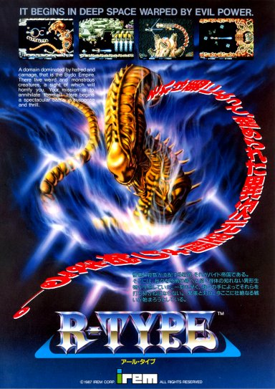

Title Art

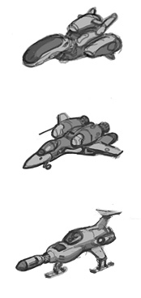Player Ship

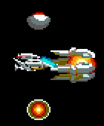

Player Ship with all upgrades (8-Bit)

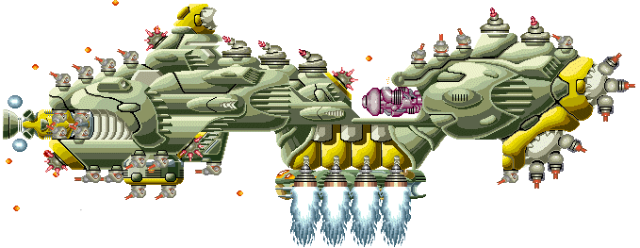

Gigantic Warship (Level 3 Boss)

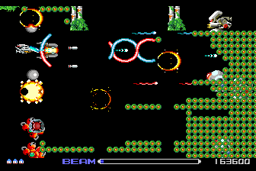

Level 4

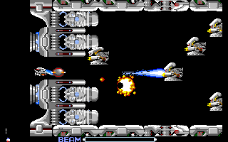

Level 1